**Report for WRO**

**Future engineers**

**Team: EPET N° 38**

**Members: Grudke Dylan Oziel, Andersson Mauro Hernán y Quintana Santino Alberto**

**Car’s name: Kaiser**

**Component’s List**

1. **Arduino UNO**

**Description**: The Arduino Uno is a development platform based on the ATmega328P microcontroller. It is one of the most popular models in the Arduino family, ideal for robotics projects due to its ease of use and extensive community support.

**Characteristics**:

* **Microcontroller**: ATmega328P.
* **Operating Voltage**: 5V.
* **Digital I/O Pins**: 14 (6 of which can be used as PWM outputs).
* **Analog Input Pins**: 6.
* **Flash Memory**: 32 KB.
* **Clock Speed**: 16 MHz.

**Advantages and Motivation**:

* **Popularity and Support**: There are countless educational resources and libraries that make its programming and use easy.
* **Flexibility**: Allows for the control and monitoring of multiple sensors and actuators, which is essential for the robot's autonomous operation.
* **User-friendly Interface**: The Arduino community provides a simple development environment that reduces the learning curve.

**Image:**

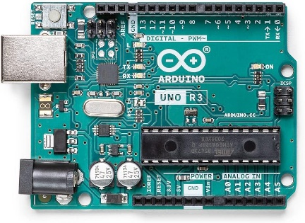

1. **2 DC Motors**

**Description:** The DC motors commonly used in educational robotics projects are direct current (DC) motors that offer a good balance between speed and torque. They are economical and relatively easy to control.

**Motivation and Advantages**:

* **Ease of Use**: These motors are compatible with a wide variety of controllers and platforms, making their integration into different projects easier.
* **Cost-effectiveness**: They are an economical option for educational projects, allowing you to maximize your budget without sacrificing performance.
* **Adequate Torque**: They provide sufficient torque to move the vehicle even on slightly uneven surfaces, ensuring smooth and stable movement.

**Image:**

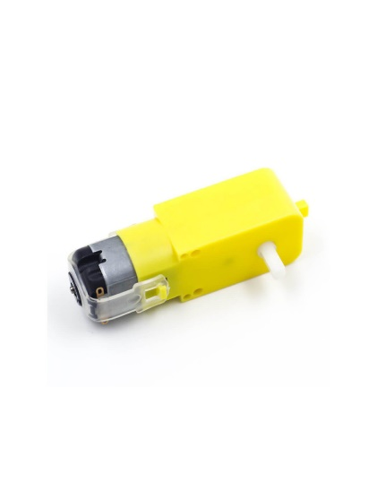

1. **Driver L298N**

**Description:** The L298N is a motor controller module that allows you to control the direction and speed of DC motors using PWM (Pulse Width Modulation) signals.

**Motivation and Advantages:**

* **Dual Motor Control**: The L298N can control up to two DC motors independently, allowing for precise management of the vehicle's direction and speed.
* **Built-in Protection**: This module includes protection diodes that prevent circuit damage in case of overcurrent or short circuits, increasing the system's durability.
* **Flexibility**: Its ability to handle currents up to 2A per channel allows it to be used with motors that require more power, ensuring adequate performance under load.

**Image:**

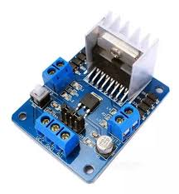

**4. Sensors and Obstacle Management**

**4.1 Ultrasonic Sensors**

**Description**: Ultrasonic sensors are used to measure distances by timing how long it takes for a sound pulse to bounce off an object and return to the sensor. In this project, they were used to detect obstacles and manage the vehicle's navigation.

**Motivation and Advantages**:

* **Measurement Precision**: Ultrasonic sensors offer precise measurements at short and medium distances, which is essential to avoid collisions with obstacles.
* **Resistance to Environmental Conditions**: Unlike other types of sensors, ultrasonic sensors are not affected by lighting conditions, making them ideal for environments with varying light levels.
* **Wide Coverage**: By placing an ultrasonic sensor on a servo motor, the environment can be scanned over a wider range, allowing the vehicle to make more informed decisions about the direction to take.

**Image:**



* 1. **Servo Motor for Steering**

**Description**: A servo motor is used to control the vehicle's steering by turning the front wheels based on decisions made by the control system.

**Motivation and Advantages**:

* **Precise Control**: Servo motors allow for precise control of the turning angle, which is crucial for maneuvering in tight spaces or adjusting the vehicle's direction when facing obstacles.
* **Fast Response**: Servo motors respond quickly to control signals, allowing for immediate adjustments in direction, which improves the vehicle's ability to avoid collisions.
* **Versatility**: Combining a servo motor with an ultrasonic sensor allows the vehicle to dynamically scan its surroundings and adjust its path in real time.

**Image:**

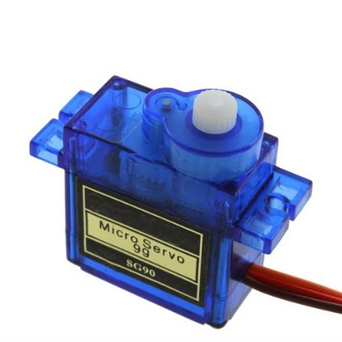

* 1. **Servo Motor for Orientation**

**Description**: An orientation servo motor is an actuator used to move an object at a specific angle. In this case, it is used to orient an ultrasonic sensor mounted on top of it, allowing the robot to detect the location of walls and decide which direction to turn.

**Characteristics**:

* **Rotation Angle**: Typically 180 degrees, although some models can rotate up to 360 degrees.
* **Precision**: High precision in angle control, allowing fine adjustments in sensor orientation.
* **Operating Voltage**: Generally between 4.8V and 6V.
* **Response Time**: Fast, allowing agile reactions to environmental changes.

**Advantages and Motivation**:

* **Precise Control**: Allows for precise adjustment of the ultrasonic sensor's orientation, improving the robot's ability to detect obstacles and plan its route.
* **Versatility**: Compatible with Arduino and easy to integrate into the robot's control system.
* **Improved Perception**: By allowing the sensor to rotate, the robot's field of vision is expanded, which is crucial for avoiding collisions and making real-time decisions.

**Image:**

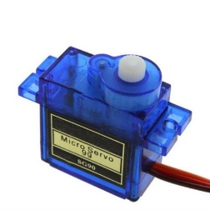

**Implementation of the Ultrasonic Sensor on the Orientation Servo Motor**

**System Description**:

* **Mounting**: The ultrasonic sensor is mounted directly on top of the servo motor. This allows the sensor to rotate and scan the environment for obstacles.
* **Connection to Arduino**: The servo motor and ultrasonic sensor are connected to the Arduino. The Arduino controls the servo motor's movement and receives data from the sensor to determine the proximity of walls or other obstacles.

**Operation**:

* **Environmental Scanning**: The servo motor orients the ultrasonic sensor in different directions, allowing the robot to scan the surrounding area.
* **Movement Decision**: Based on the sensor data, the Arduino decides which direction the robot should turn to avoid obstacles and continue its route.
  + 1. **Acrylic Chassis**

**Description**: The vehicle's chassis is made of acrylic, a lightweight and durable material that provides a solid base for mounting components.

**Motivation and Advantages**:

* **Lightweight**: Acrylic is a lightweight material that reduces the vehicle's overall weight, which translates to lower energy consumption and greater movement efficiency.
* **Durability**: Despite its lightness, acrylic is strong enough to withstand minor impacts, protecting the electronic components mounted on it.
* **Ease of Modification**: Acrylic is easy to cut and drill, allowing modifications or adjustments during project development without the need for specialized tools.

**Image:**



* + 1. **Jumpers Male-Female, Female-Female, and Male-Male**

**Description**: Jumpers are cables with connectors at both ends that are used to make connections between different electronic components, such as between the Arduino and other modules.

**Characteristics**:

* **Connectors**: They can be male (pin) or female (socket).
* **Length**: Varies according to needs, commonly between 10 and 30 cm.
* **Compatibility**: Used for connections on breadboards and between electronic modules.

**Advantages and Motivation**:

* **Flexibility**: Allows for easy reconfiguration of the circuit, ideal for quick tests and adjustments.
* **Organization**: Facilitates the orderly connection of components, reducing clutter and potential connection errors.
* **Insulation**: The connectors are covered by insulating material, preventing short circuits and protecting the components.

**Image:**

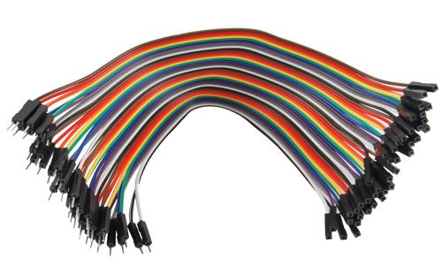

* + 1. **Wheels**

**Description**: Wheels are fundamental mechanical components in any mobile robot, as they enable the vehicle to move. They are designed to support the robot's weight and facilitate movement on different surfaces.

**Characteristics**:

* **Material**: Generally made of plastic, rubber, or a combination of both. Rubber wheels provide better traction on smooth surfaces.
* **Diameter**: Commonly between 5 cm and 10 cm, depending on the robot's design and competition requirements.
* **Width**: The width of the wheel influences the robot's stability and traction. Wider wheels usually provide greater stability.

**Advantages and Motivation**:

* **Traction and Stability**: Rubber wheels offer reliable traction on various surfaces, which is crucial for precise maneuvers on the competition track.
* **Versatility**: Wheels can be selected according to the project's specific needs, such as speed, traction, and terrain type.
* **Ease of Implementation**: Wheels are easy to mount and are usually compatible with different motors and axles, facilitating their integration into the robot.

**Image:**

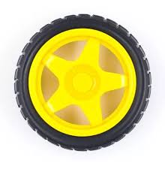

**8. Switches**

**8.1 Switch 1: Powering the Arduino**

**Description**: This switch is a power switch that controls the power supply to the Arduino. When this switch is activated, current is supplied to the Arduino, which powers it on and allows it to begin functioning.

**Characteristics**:

* **Type**: It can be a toggle switch, push button, or slide switch.
* **Operating Voltage**: Compatible with the Arduino's power supply voltage (typically 5V or 12V, depending on the configuration).
* **Current Capacity**: Must support the current required to power the Arduino, usually low (on the order of milliamps).

**Advantages and Motivation**:

* **Direct Energy Control**: Allows you to power the Arduino on or off easily, which is useful for conserving energy and restarting the system when necessary.
* **Simplicity**: Easy to implement in the power circuit, providing a direct method for controlling the Arduino's state.

**Image:**

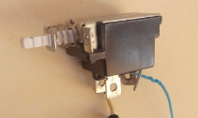

**8.2 Switch 2: Start Programming**

**Brief Description**: This second switch is an input switch that, when activated, sends a signal to the Arduino to initiate the execution of the programmed code. It is typically used to start the robot's control sequence, such as the beginning of a mission or specific task.

**Characteristics**:

* **Type**: Momentary push button, which only sends a signal while pressed.
* **Connection**: It connects to one of the Arduino's digital pins configured as input.
* **Debounce**: It is important to implement "debounce" in the code to avoid erroneous readings due to mechanical switch bouncing.

**Advantages and Motivation**:

* **Precise Control**: Allows the program to start at the exact desired moment, which is crucial for synchronizing the robot's actions with the competition.
* **Design Flexibility**: You can program the Arduino to react in different ways depending on the switch's state, making it easier to control multiple functions or operating modes.

**Image:**

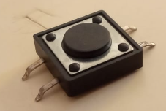

* + 1. **LEGO EV3 Parts for Component Assembly**

**Description**: LEGO EV3 parts are modular blocks specifically designed for robot construction. They are part of the LEGO Mindstorms EV3 educational robotics system, which includes a variety of components such as beams, connectors, and axles that facilitate the assembly of robust structures.

**Characteristics**:

* **Material**: ABS plastic, known for its durability and strength.
* **Compatibility**: Fully compatible with other LEGO systems, allowing integration with different robotics kits.
* **Variety**: Includes beams, connectors, axles, gears, and other parts that can be used to build structures and mobile mechanisms.

**Advantages and Motivation**:

* **Modularity and Flexibility**: LEGO EV3 parts allow for quick assembly and disassembly, facilitating iterative design of the robot.
* **Precision in Assembly**: Thanks to their design, the parts allow for precise assembly of components, ensuring they remain securely in place during the robot's operation.
* **Ease of Use**: They do not require additional tools for assembly, simplifying the mounting process and allowing for quick adjustments during testing and competition.

**Image:**

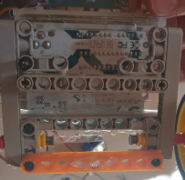

**10. Protoboard**

**Description**: A protoboard, also known as a breadboard, is an essential tool for creating and testing electronic circuits without soldering. It allows components to be connected quickly and easily, which is ideal for making adjustments and modifications during the robot's development.

**Characteristics**:

* **Size**: Protoboards vary in size, but the most common have between 400 and 800 connection points.
* **Distribution**: They are organized in rows and columns with connection strips that facilitate the interconnection of components.
* **Versatility**: Compatible with most electronic components, including resistors, capacitors, LEDs, and microcontrollers such as Arduino.

**Advantages and Motivation**:

* **Ease of Use**: Does not require soldering, allowing for quick changes in the circuit during testing.
* **Reusability**: Components can be easily inserted and removed, making it ideal for iterative testing and prototyping.
* **Organization**: Helps keep the circuit organized and understandable, making it easier to identify and solve problems.

**Image:**

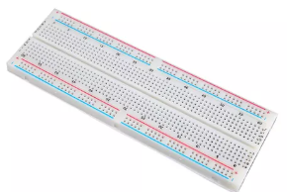

**11. AA Battery Holder and Dlyfull Rechargeable Batteries**

**11.1 AA Battery Holder**

**Description**: An AA battery holder is a container that holds multiple AA batteries, organizing them in series or parallel as needed. This device facilitates the connection of batteries to an electrical circuit, providing a reliable power source for the robot.

**Characteristics**:

* **Capacity**: Generally designed to hold 2, 4, or 6 AA batteries.
* **Connections**: Battery holders come with terminals that allow direct connection to the robot's circuits via wires or connectors.
* **Material**: Made of durable plastic with metal contacts for good conductivity.

**Advantages and Motivation**:

* **Mobility**: Its compact and lightweight design facilitates integration into the robot without adding excessive weight.
* **Versatility**: Can be easily mounted anywhere on the robot using LEGO EV3 parts or specially designed mounts.
* **Reliability**: Provides a stable way to hold the batteries in place, ensuring continuous power supply without accidental disconnections.

**Image:**

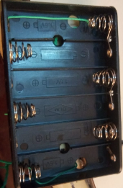

**11.2 Dlyfull Rechargeable Batteries**

**Brief Description**: Dlyfull rechargeable batteries are high-quality batteries designed to be recharged and reused multiple times, offering an eco-friendly and economical option for powering the robot.

**Characteristics**:

* **Type**: Generally NiMH (Nickel-Metal Hydride), known for their capacity and durability.
* **Capacity**: Varies depending on the model, commonly between 1000mAh and 2800mAh per battery.
* **Voltage**: Each battery provides a voltage of 1.2V, slightly lower than standard alkaline batteries (1.5V), but sufficient for most circuits.
* **Recharge Cycles**: Can be recharged several hundred times, extending their lifespan compared to disposable batteries.

**Advantages and Motivation**:

* **Energy Efficiency**: They offer stable capacity during their discharge cycle, which is crucial to maintaining the robot's performance during competitions.
* **Long-term Savings**: Although they are initially more expensive than disposable batteries, their rechargeability makes them a cost-effective long-term option.
* **Environmental Impact**: Rechargeable batteries reduce the amount of electronic waste generated, supporting a more sustainable practice.

**Image:**

